# Get Team Names with a Subquery

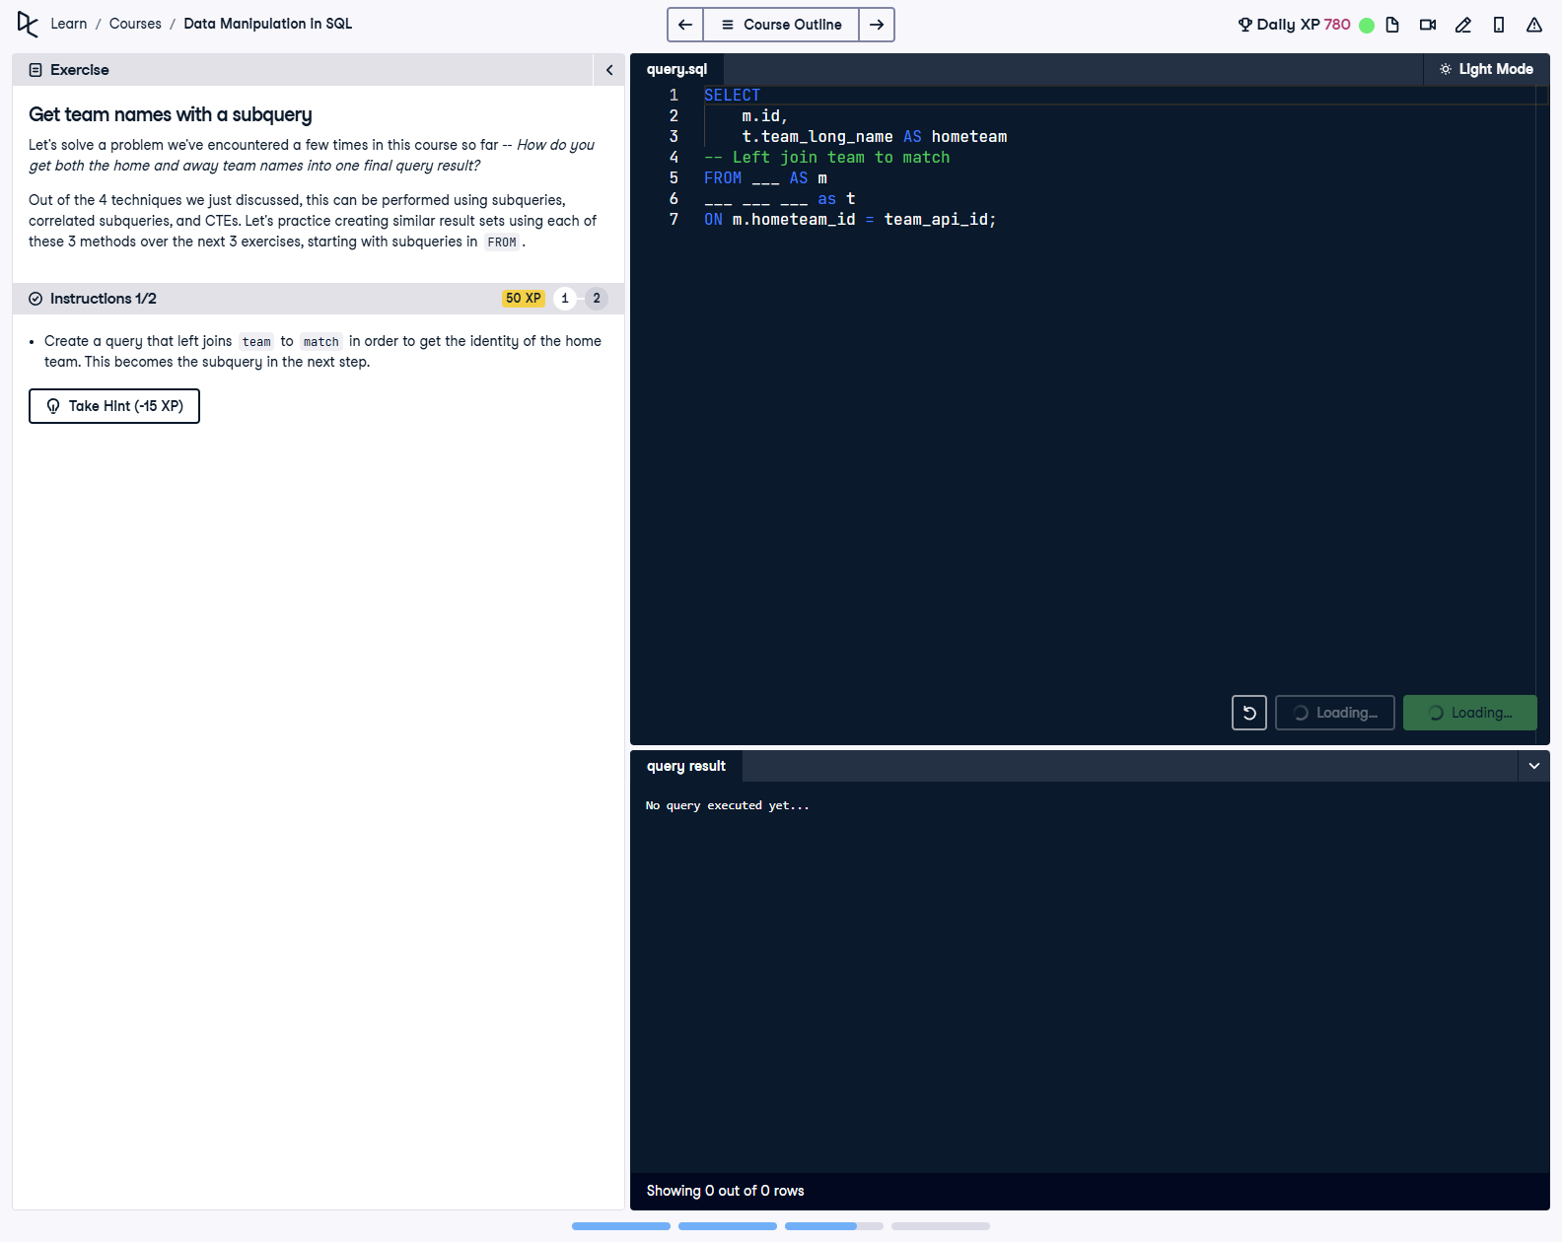

## Question

1. Create a query that left joins team to match in order to get the identity of the home team. This becomes the subquery in the next step.

## Corrected Solution

SELECT  
 m.id,  
 t.team_long_name AS hometeam  
-- Left join team to match  
FROM match AS m  
LEFT JOIN team AS t  
ON m.hometeam_id = t.team_api_id;

## Explanation

This query retrieves match IDs and the names of the home teams by performing a LEFT JOIN between the match and team tables. The match table (aliased as m) contains the hometeam_id column, which is matched to the team_api_id column in the team table (aliased as t). The query selects the match ID and the full name of the home team (renamed as hometeam), preparing a subquery that can be used for further analysis in the next steps.